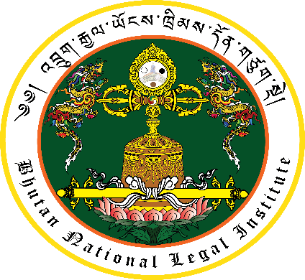

**༄།འབྲུགརྒྱལ་ཡོངས་ཁྲིམས་དོན་གཙུག་སྡེ།**

**Bhutan National Legal Institute**

**Lecture Program (24.4.2019)**

|  |  |  |
| --- | --- | --- |
| **Time** | **Event** | **Remark** |
| 10:00 | Students and faculty members to be seated in the Lecture Theatre | B.Ed Final Year and PGDE Students |
| 10:05 | Arrival of the Hon. Chief Justice of Bhutan | To be received by the Judicial and College officials |
| 10:10 | Phebja | Paro College of Education |
| 10:30 | Marchang | Paro Drangpon |
| 10:40 | National Anthem | All |
| 10:45 | Welcome | Officiating President,  Paro College of Education |
| 10:50 | Objectives of the Lecture Series | Director General, Bhutan National Legal Institute |
| 11:00 | Lecture by the Hon. Chief Justice | 1 hour |
| 12:00 | Question and Answer Session | 30 minutes |
| 12:30 | Vote of Thanks | Dean of Student Affairs,  Paro College of Education |
| 12: 40 | *Zhabten* of His Majesty the King and *Desheg Tempa* | All |
| 12:50 | Group Photography with the Hon. Chief Justice of Bhutan | All |
| 13:00 | Departure of the Hon. Chief Justice to Thimphu | To be seen off by the Judicial and College officials. |