འབྲུག་རྒྱལ་འཛིན་གཙུག་ལག་སློབ་སྡེ།
PARO COLLEGE OF EDUCATION

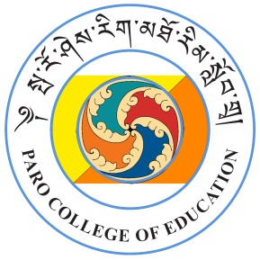
Hon’ble Vice Chancellor’s Visit
26 August 2026

PROGRAMME

Reception

10:25am | Deans, PLs, Administrative Officer, and Student Representatives receive Hon’ble Vice Chancellor Dasho Chewang Rinzin and team
10:30am | Arrival of the Hon’ble Vice Chancellor
10:35am – 11:00am | Reception Tea at the Faculty Lounge, Nangkar-Choling
Meeting with Students

10:55am | Students are seated in the Centenary Gymnasium
11:00am | Arrival of the Hon’ble Vice Chancellor
11:00am-11:05am | Welcome note by the Officiating President
11:05am – 12:45am | Meeting with the Students
12:45 am – 12:55 am | Awarding Vice Chancellor’s Reading Excellence Award
12:55am - 1:00pm | Closing remark by the Chief Student Councillor
1:00pm – 2:00pm | Lunch at the Pavilion (Nangkar-Choling campus)
Meeting with Staff (Teaching and Non-Teaching)

2:00pm | Staff (Teaching and Non-teaching) are seated in Manjushri Hall (Nangkar-Choling)
2:05pm | Arrival of the Hon’ble Vice Chancellor
2:05pm – 4:00pm | Hon’ble Vice Chancellor’s address
4:00pm- 4:10pm | Closing remark by the Dean of Academic Affairs
Departure Programme for Hon’ble VC
4:15pm – 5:00pm  5:00pm | Refreshments with staff at Manjushri Grove of Harmony  Hon’ble Vice Chancellor Departs



