To:
The President
Paro College of Education
Thimphu; Bhutan
Subject: Request for Support – Mindful Technology & Cultural Collaboration Initiative
Dear Sir/Madam,
Warm greetings from Green E-Integrated Private Limited (GEIPL).
We are pleased to inform you about our upcoming Mindful Technology & Cultural Collaboration Initiative, scheduled to be held on 03-03-2026 from 10am at your esteemed institution. This three-hour program is designed to introduce students to the Guru App, a Bhutanese digital platform that supports mindful spiritual practice while encouraging reflection, discipline, and cultural connection.
In order to successfully conduct the session, we kindly request your support with the following:
- Appointment of a focal person from your college for coordination
- Access to the MPH (Multipurpose Hall) as the program venue
- Provision of a projector
- Microphones and sound system
- Arrangement of a few chairs and a table on stage for the Q&A session
While we would be especially grateful for the opportunity to engage with your college clubs and their members, the program will remain open to all interested students.
We believe this collaboration will provide meaningful value to your students by blending technology with Bhutanese cultural and spiritual practices. We would be honored to work closely with your institution to make this initiative impactful.
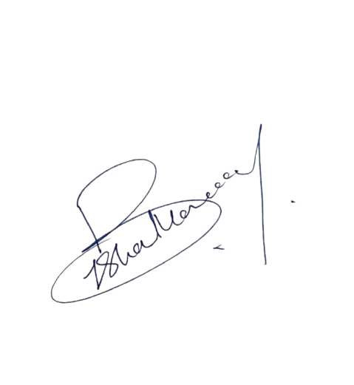
We kindly request your support and confirmation at your earliest convenience. For any further information, please feel free to contact us at [contact details].
Thank you for your continued support and partnership.

Yours sincerely,
Bishal Monger
Marketing Officer – Guru App
Contact: +975-17422921
Email: bishalmonger27@gmail.com

