**Kinzang Choden**

**4PCA**

Student ID: 06180144

CID: 10605003412

Date of Birth: 17/06/2000

Skills

* Self-development
* Team development
* Positivity
* Active listener
* Accountability

Work Experience

* Class captain (2015)
* Class captain (2017)
* Science Club coordinator (2015)
* Class coordinator (2020-2021)
* Currently serving as interim councilor.

***I don’t just speak the change, I make the change and I am your voice.***

If I ever get to be a councilor my goals are as follows:

1. I promise to bring more good things to life from the little things I can do.
2. I promise to serve with enthusiasm, dedication, and integrity.
3. Protect the rights and comfort of my fellow mates at the best diction.
4. Be true to the college goals.
5. Be the manifestation and voice of my fellow mates.

Thank you and VOTE for the best.

CV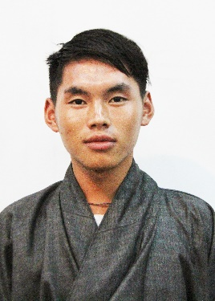

Name: Thinley Dorji

Student ID: 06180160

CID no. 11515001479

Past experiences:

1. Served as house captain in class 6
2. Cultural captain in class 7
3. Health captain in class 8
4. House captain in class 8
5. Bell master in class 8
6. Class coordinator in 1st and 2nd year in the college.

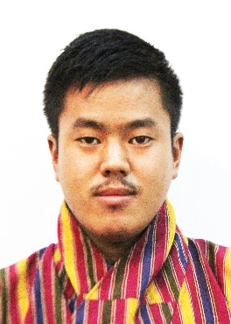

Name: Thinley Dorji

SID: 06180216

**House captain (class 6)**

**Class captain (7-10)**

**School Captain (11-12)**

**Class captain (2nd year & 3rd year)**

**Interim Councilor**